Friends of Olympic Valley Position Paper
Palisades Tahoe’s Revised EIR

For Presentation to the Placer County Planning Commission
January 19, 2023, 10 AM
North Tahoe Event Center, 8318 N. Lake Boulevard, Kings Beach, California

Questions can be addressed to:
friendsofsv@gmail.com

TO: Placer County Community Development Resource Agency, Environmental Coordination
Services, 3091 County Center Drive, Suite 190, Auburn, CA 95603;

Email: cdraecs@placer.ca.gov

no later than 5:00
p.m. on January 30, 2023

Introduction
Friends of Olympic Valley (formerly Squaw Valley) is a group of concerned Olympic Valley residents who advocate for maintaining and improving the quality of life in the Valley. The Friends’ group was formed in response to the original developer’s (KSL) overreach in expanding the existing Village. Additionally, Friends of Olympic Valley is the primary sponsor of the Olympic Valley Firewise Program.
It is important to note that the Friends have always been a proponent of an expanded village in Olympic Valley – albeit smaller in size.
The Revised EIR (REIR) does not address the major and substantial changes with the climate, environment and economy that have occurred since the original plan was approved by the Board of Supervisors in 2016. Great harm will come to Olympic Valley if the REIR as submitted does not analyze these changes.
It is the Friends’ position that there are in fact significant and “severe environmental” changes within Olympic Valley, the Route 89 evacuation route, the Lake Tahoe Region and the surrounding area (Truckee, Reno, Alpine Meadows etc.), that should require Palisades Tahoe to develop an entirely new Village EIR.
The Revised EIR does not address any of these changes, and unfortunately only deals with issues raised by the Appellate Court. Palisades Tahoe mistakenly states “no new information or new circumstances exist that would warrant a complete revision of the original EIR” ….
"Further, consistent with the requirements of PRC (Section 21166) and CCR (Section 15162), a lead agency shall not address any other issues (outside those specified in the Ruling) considered in a certified EIR unless substantial evidence demonstrates that (1) substantial changes would occur to the proposed project leading to new or substantially more severe significant effects; (2) substantial changes with respect to the circumstances under which a project is undertaken would result in new or substantially more severe significant effects; or (3) new information which was not or could not have been known with the exercise of reasonable diligence at the time the EIR was certified shows that new or substantially more severe significant impacts would occur." (Page 1-8, Revised EIR)
“Finally, there is no known new information that would result in new or substantially more severe environmental impacts since certification of the EIR 6 years ago. Therefore, this REIR addresses only those issues raised in the Ruling. No other chapters or portions of the 2016 EIR are addressed in this REIR as no new information or new circumstances exist that would warrant revision of these other chapters or portions”. (Page 1-8, Revised EIR).
We disagree. The following “severe environmental”, social, economic and legal changes since 2016 clearly warrant a completely new EIR review:
- Extended multi-year drought conditions
- Olympic Valley water supply
- Increased risk of wildfire
- Transportation and lack of realistic evacuation route
- Increased tourism placing strain on Lake Tahoe Region
- Increased real estate values
Friends believe that in view of the aforementioned impacts, the Revised EIR should be rejected and Placer County must demand that a completely new EIR be developed. Details follow.
Extended, Multiyear Drought Conditions
California is now in a four-year drought that not only increases the risk of controlling wildfires, but is putting our entire drinking water supply at risk. It is clear that climate change has fundamentally altered our state’s hydrologic system, intensified extreme weather and is leading to longer, drier periods.
- We are entering a fourth year of drought (Source: California Water Watch.ca.gov)
- The 2022 Water Year ended with total annual average statewide precipitation at 17.9" and 76% of percent of historical average. Statewide reservoir storage ended the water year at 14.70 Million Acre Feet, 69% of historical average.

The U.S. Drought Monitor, recently reported the entire state is at “abnormally dry” conditions. Close to 98% is experiencing “moderate drought” conditions, 80.6% of the land is in “severe drought,” 35.5% of the state is in “extreme drought”. And 7.16% of the state is suffering “exceptional drought conditions.”
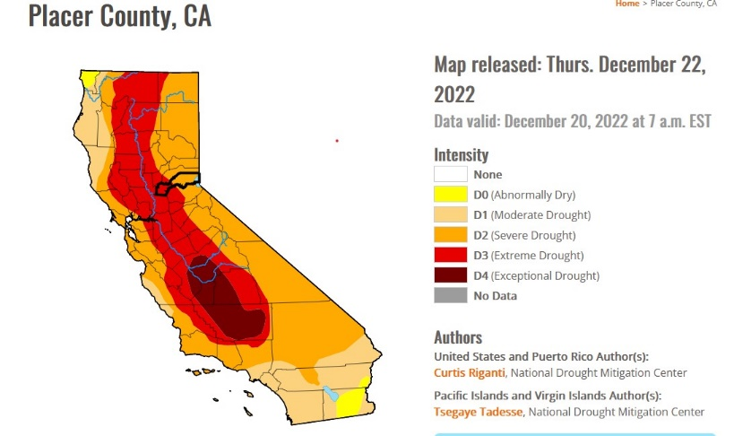
With regard to Olympic Valley, we have now experienced below average snowfalls for 6 of the last 7 years (Source: Palisades Tahoe website).

- Between 2002 and 2011, the snowpack in the Sierra was 100% or more of the historic average for six winter seasons. But in the last decade, it has only reached that marker twice.
- Eight of the top 10 warmest years on record occurred in the last decade and are not factored in the Revised EIR

The combination of the Region’s drought, the multi-year below average snowfalls and the growing concern over climate change dictates that Placer County require Palisades to provide detailed analysis on these effects in a new EIR. They were clearly not factored into the original EIR:

“Any more detailed quantitative analysis of the specific effects of climate change on Olympic Valley groundwater conditions without specific information on how climate change will affect specific precipitation patterns in Squaw Valley would be speculative, unsubstantiated, and uncertain”. (Source: Palisades Tahoe Final EIR 3.17)

Finally, while the time period used to calculate future aquifer levels in the Final EIR (2015 Water Supply Assessment (WSA) included the years 2012 through December 2014, the WSA needs to be updated to include the most recent years (2016 – 2022) as they include some of the worst drought years, and better reflect the current state of climate change.

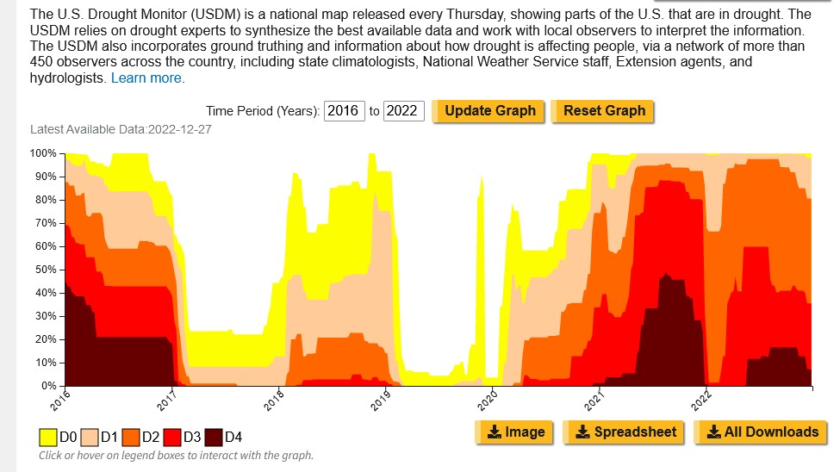

DO Abnormal Dry - D1 Moderate Drought - D2 Severe Drought - D3 Extreme Drought - D4 Exceptional Drought

It needs to be pointed out that the WSA seeks to determine, after the construction is completed, what happens to the aquifer level under “looking backwards” conditions. Unfortunately, new research shows that our drought may extend well into the future and challenge even our most basic understanding of the Olympic Valley Aquifer and how water accumulates.
In a study, the Sierra Nevada snowpack, a major source of water for California, could largely disappear in 25 years if global warming continues unchecked, according to recent research conducted by the Lawrence Berkeley National Laboratory (Source: Oct. 26 Journal Nature Reviews Earth & Environment):
- "A low-to-no-snow future has massive implications for where and when water is stored in the western U.S.," Erica Siirila-Woodburn, a hydrologist at the Lawrence Berkeley National Laboratory
In a study conducted by UCLA Center for Climate Science in 2018 it was determined:
- The Sierra Nevada elevations most vulnerable to climate change are 5,000–8,000 FEET This is where snow albedo feedback is occurring — a cycle of amplified warming and snowmelt due to loss of reflectivity.
- Warming sets the stage for snow loss by causing more precipitation to fall as rain instead of snow, and snow to melt faster.
- Being able to save water that comes in winter for the hotter months is critical to our economy and way of life. Manmade reservoirs can store some of that water, but not all of it. Snowpacks are the natural solution to storing water.
Finding: The realities of climate change need be addressed in a new EIR which should incorporate an updated Water Supply Assessment (WSA) that includes the most recent drought years.

Finding: As snow is the primary method of replenishing the sole aquifer that we rely on for water, the scale of development within the Valley must be rethought.

Olympic Valley Water Supply

It is important to note that there is only one aquifer within the Valley that supplies all of our water needs.

To repeat… there is no backup water supply for the Valley.

One key misassumption stated in Chapter 3.1.1 of the original EIR is that the Squaw Valley Public Service District (SVPSD) is studying the feasibility of obtaining a redundant source of water for Olympic Valley.

- In connection with this effort, the SVPSD is studying various pipeline routes from Martis Valley, among other options, to secure a redundant source of water

It is clear that Palisades Tahoe understands the importance of this issue as noted in the original EIR…

“Very few water systems rely on a single source of water, and
the SVPSD seeks geographic diversity for its water supply system”

Finding: The Olympic Valley Public Service District (OVPSD) has made no progress on finding an alternative water supply as stated in Chapter 3.1.1 of the EIR. Placer County should demand that this issue of a redundant water supply be revisited in a new EIR.

Because of accelerating climate changes, realistic consumption plans of the Mountain Adventure Camp in original EIR should be also addressed in a new EIR. Since there are no detailed plans on what interior structures (pools, slides, etc.) will be installed in the Camp it is impossible to know whether the estimate of water usage included in the original EIR is accurate.
- Palisades has estimated that the building will use 756 gallons per day
- If accurate, the Camp’s water usage will exceed 20,000 gallons of water per month
- That totals 240,000 gallons per year

It will be a failure on the part of Placer County to not demand more data in a new EIR on what structures will be included in the Camp and what the Camp’s actual water usage will be.

Finding: Palisades Tahoe should be required to provide accurate water consumption usages for the Mountain Adventure Camp not listed in the original EIR or Revised EIR.

The aquifer in the western part of the Valley is the main source of potable water for the two water companies in the Valley, the Mutual Water Company and the OVPSD. This aquifer is quite shallow and is no more than 18 feet deep. Because of climate change which is associated with higher and higher temperatures, the snowpack will be diminished because there will be more rain than snow than in the past. The reduced snowpack combined with a shallow aquifer mean that total water capacity over time will be less than it has been historically. Therefore, there will be an increased risk of water shortage earlier in the season, typically late summer/early fall.

California legislation has amended two existing water supply statutes since the original WSA was conducted. The amendments attempt to incorporate certain Sustainable Groundwater Management Act (SGMA) requirements into the statutes to add further guidance regarding water supply planning for California Environmental Quality Act (CEQA) development projects. On January 1, 2017, California Senate Bill 1262 (SB 1262) became effective. SB 1262 amends California Water Code § 10910 and California Government Code § 66473.7 in an initial attempt to incorporate requirements under California's Sustainable Groundwater Management Act (SGMA).

This change in California law allows a forward-looking assessment of future water supply taking
into account rising temperatures and possible more severe drought conditions than in the past.

Finding: The 2015 Water Supply Assessment looked only backward at historical use of and demand for water. Since that study was done California law now allows the assessment of future climate change in determining water supply. Specifically for Olympic Valley, the rising temperatures due to climate change and subsequent reduced snowpack will negatively impact water supply, particularly in mid to late summer. The OVPSD and Placer County need to call for an updated WSA with this additional forward-looking analysis.

Increased Risk of Wildfire

Our understanding of the risk of wildfire (within Olympic Valley as well as to the single evacuation route on Route 89) has dramatically increased since the original Palisade EIR was completed in 2016. The “wildfire factor” alone warrants a complete redo of the EIR since both the original EIR and the Revised EIR fail to consider new research about the risk of wildfire in Olympic Valley and in high elevation locations.

What is surprising is that the Revised EIR relies on the opinions and views of the former fire chief of Olympic Valley who retired in 2017. To quote the Revised EIR….

Chief Bansen identified that the Olympic Valley “is pretty favorable in terms of fuels
and topography and the unlikely host event for a large wildfire.” (Page 15-15)

To that point, the Olympic Valley Public Service District (PSD) published the Olympic Valley Community Wildfire Protection Plan in 2022. A Community Wildfire Protection Plan (CWPP) identifies and prioritizes areas for hazardous fuel reduction treatments and recommends the types and methods of treatment on Federal and non-Federal land that will protect one or more at-risk communities and essential infrastructure and recommends measures to reduce structural ignitability throughout the at-risk community. The CWPP can be viewed at the following link:

Olympic Valley Community Wildfire Protection Plan
The Olympic Valley Community Wildfire Protection Plan (2022) contradicts the opinions of Chief Bansen which Palisades Tahoe relied on in the Revised EIR. The CWPP plan notes:
Located in the middle of tens of thousands of acres of wildland, with hundreds of
wooden homes and commercial structures, the Olympic Valley community has a very
high exposure to catastrophic wildfire losses

Finding: Palisades Tahoe which partially funded the CWPP did not include the CWPP findings in the Revised EIR even though the CWPP was published well in advance of the release of the Revised EIR. The severe risk of wildfire particularly along RT89 demands a redo of the entire EIR.

Finding: The REIR relies significantly on the views of retired Chief Bansen. As noted above most of his views have now been refuted with scientific studies that have been published since the original EIR was created. Wildfire risk to the Valley and RT 89 Corridor needs to be addressed in a completely new EIR.

The Olympic Valley CWPP not only includes details in the high risk of wildfire within the Valley itself, but includes a significant portion of the R8 89 evacuation corridor. As the following map shows there are numerous “high risk” wildfire areas along the evacuation corridor.

Olympic Valley Community Wildfire Protection Plan (Valley plus Rt89 corridor)

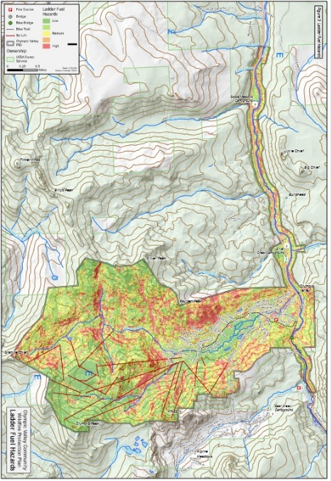

There is additional Wildfire research published since 2016 that supports our claim that a new EIR should be required.

In 2022 - six years after the original EIR was certified - the California Office of the State Fire Marshall revised its Wildfire map that further substantiates the research of the Olympic Valley CWPP. The bright red on the following Fire Marshall map indicates the wildfire high risk area along the Rt 89 evacuation route.
State Fire Marshal Wildfire Risk Map Rt 89 Highlighted
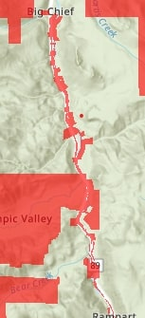

Additional wildfire research since the original EIR was published supersedes previously held opinions on the risk of wildfire in our area.
- Forest fires of the western United States have advanced upslope over the past few decades, scorching territories previously too wet to burn - up to 2500m elevation. (Source: Proceedings of the National Academy of Sciences, May 2022)
Another “severe environmental change” that has happened since the original EIR was produced is that the Granite ridges on either side of Olympic Valley and the Rt 89 Corridor are no longer protection against wildfire jumps.
- Caldor Fire became the second fire in California history to cross the Sierra Nevada, traveling up and over the highest ridgetops.
- “We haven’t had fires burn from one side of the Sierra to the other,” Cal Fire Director Thom Porter said “We did with the Dixie; now we have with the Caldor — two times in our history, and they are both happening this month"

These ridges were once believed to be a key protection for the Valley.

- There is a plan by the US Forest Department to reduce the risk of wildfire on 1080 acres of forest between Alpine Meadows and Olympic Valley.
- But the project remains unfunded (estimated cost $2.4M) and the USF is asking for private donations.
Further evidence of “change” is that the USFD Five Creek Project along Rt 89 (which was approved in 2022) demonstrates the high risk to the evacuation route:
The proposed project would complete fuels reduction, forest restoration, habitat enhancement, invasive plant treatments, and road management actions on approximately 6,000 acres along the highway 89 corridor south of Truckee, California.
Finally, new Cal Fire Maps are expected this year and should also be factored into a new EIR:
CAL FIRE is required by law to map areas of significant fire hazards based on fuels, terrain, weather, and other relevant factors. These designations, referred to as Fire Hazard Severity Zones (FHSZ), mandate how people construct buildings and protect property to reduce risk associated with wildland fires. The maps were last updated in 2007-2010. The FHSZ draft maps are currently being finalized for the State Responsibility Area (SRA), where the State (CAL FIRE) is responsible for wildland fire protection, suppression, and prevention. This new data will be available in late 2022 or 2023. Mapping of the areas, referred to as Very High Fire Hazard Severity Zones (VHFHSZ), is based on data and models of, potential fuels over a 30-to-50 year time horizon and their associated expected fire behavior, and expected burn probabilities to quantify the likelihood and nature of vegetation fire exposure to buildings. The Olympic Valley is an SRA and except for the meadow area, the entirety of the community and surrounding area is in a VHFHSZ.
Finding: New wildfire research published since the certification of the EIR 2016, should in itself dictate that Placer County demand the creation of a new Village EIR.
Finding: The RT 89 corridor is now considered (since the original EIR was published) a high-risk area for wildfire. Allowing the Applicant an 11-hour evacuation timeline which is an increase from the original EIR is illogical. The Village project should be scaled back to reduce the evacuation timeline.

Transportation
The Palisades Tahoe Revised EIR attempts to cure the transportation deficiency cited by the Courts through expanded use of TART. While on the surface this approach appears to address the issue, it fails to deal with the new realities of our transportation problem.
- Lack of stable housing options for workers is one of the most significant threats to quality of life in the Tahoe Region (Tahoe Prosperity Center March, 2022)
- Revised EIR Transportation section (Chapter 9) does not take into consideration the fact that local workers are commuting further and further to work at Palisades Tahoe
  - As identified on page 9-65 of the 2016 DEIR up to 550 project-related employees may be expected to work in the Village Area and reside outside of Olympic Valley.
  - Palisades Tahoe recruiting in Reno and Sacramento for workers with no employee housing offered (Source: Indeed.com and PT website)
  - There is still no plan on dealing with daily skiers that exit RT 80 (parking etc.)
  - Without adequate parking in Truckee TART plan detailed in the Revised EIR will not work
- The severely congested Olympic Valley Road and Rt 89 this year (Gondola opening week and 12/29/2022) highlights risk of depending on PT for executing proper evacuation plan during peak times
- Lack of progress in developing three-lanes on Rt 89 plan hampers an evacuation plan
- Palisades Tahoe is proposing an 11-hour evacuation plan using a two-lane road travelling through a high-risk fire zone
Neither the Revised EIR nor the original 2016 EIR’s “shelter in place” plan has any details regarding protection from flying embers, breathable air, water, food, toilets, medical support, etc. The Revised EIR does mention that the parking garages will be used for shelter in place but does not address any of the items listed above. Details on removing cars from the structures quite likely loaded with gasoline etc. are examples of items missing from the plan.
Further, the recent decision of the California Air Resources Board (CARB) to ban the sale of new gas furnaces and water heaters beginning in 2030, requires that the fuel choices for the new Village dictate a new EIR, especially since alternative fuel sources would dramatically reduce the risk of wildfire within the Valley.
Finding: The original EIR underestimated the demand for local employee housing, ignores the lack of affordable housing in the area and overestimates the ability of TART to effectively solve the commuting issue of workers into and out of the Valley. This along with inadequate TART parking for RT80 day skiers needs to be addressed in a new EIR.
Finding: Neither the Revised EIR nor the original 2016 EIR’s “shelter in place” plan has any details regarding protection from flying embers, breathable air, water, food, toilets, medical support, etc.
Finding: The reliance on propane to fuel the new Village needs to be re-imagined in a new EIR based on the State’s directive to ban the sale of gas furnaces during the time period of Village development.

Increased Tourism placing strain on Lake Tahoe Region
Fodor’s issued tourist travel warning for Lake Tahoe due to overcrowding:
  - Fodor’s Travel placed Lake Tahoe on its annual "No List," designating the popular Northern California mountain destination among 10 locations around the world travelers should rethink if they’re planning a visit in 2023.​ Tahoe fell under the category of "natural attractions that could use a break," as Fodor's proclaimed that "Lake Tahoe has a people problem."
“Tahoe’s limited roadways become congested when thousands of people who live in nearby metropolitan areas get in their cars and drive up to our small mountain communities,” Joanne Marchetta, executive director of the Tahoe Regional Planning Agency (TRPA), “Suddenly, a road system designed for 55,000 residents must handle four to five times that many cars.”
As noted previously, Palisades Tahoe is proposing an 11-hour evacuation plan using a two-lane highway that travels through a number of high-risk fire zones.
- Considering the updated cumulative project information provided in Appendix F, this evacuation time would increase by approximate 22 minutes to roughly 11.1 hours. (Source; page 15-13 REIR)
While the Revised EIR takes into consideration additional construction since 2016 (page 15-12) and its effects on the evacuation times…
“When considering the total effect of withdrawn projects, new projects, and the absorption of anticipated future development potential by new projects, there is no net increase in Olympic Valley cumulative development projections for residential and resort/hotel/condo units compared to the cumulative development scenario in the 2016 EIR”
We disagree. This conclusion does not take into consideration the increase in tourists in the Lake Tahoe Region (outside Olympic Valley), nor does it take into consideration the ability for existing second homeowners to work remotely thereby increasing the traffic load on the RT 89 “Mousehole” and traffic circles on RT 89 and RT 80.
Finding: It is not enough to determine the load on the existing roads using new construction starts since 2016. A revised evacuation study needs to be developed in a new EIR that take into consideration the increased density of people and cars in existing homes and hotels due to Covid migration, remote working and increased visitor days within the Region.

Increased Real Estate Values
Due to the dramatic increase in the region’s real estate values, and in particular Olympic Valley, there are now an increasing number of viable smaller Village plans that would satisfy CEQA and achieve the financial goals of the Applicant. This is significant “new circumstance” that dictates that Palisades Tahoe be required to produce a new EIR (Page 1-8, Revised EIR).

The California Code of Regulations (CCR) Section 15126.6(a) (State CEQA Guidelines) requires EIRs to describe “... a range of reasonable alternatives to the project, or to the location of the project, which would feasibly attain most of the basic objectives of the project but would avoid or substantially lessen any of the significant effects of the project, and evaluate the comparative merits of the alternatives.
CCR Section 15126.6. An EIR should identify the “environmentally superior” alternative. “If the environmentally superior alternative is the ‘no project’ alternative, the EIR shall also identify an environmentally superior alternative among the other alternatives.”

According to the original EIR (Section 17.3.8) while Palisades Tahoe acknowledged at the time that while there was a smaller Village that reduced impacts to our community, they noted that the financial viability of the smaller plan was unknown:
The Reduced Density Alternative is the environmentally superior alternative of the other alternatives considered. With this alternative, significant impacts to housing, biological resources, cultural resources, visual resources, traffic, air quality (operations), noise, and greenhouse gases would be reduced or avoided, when compared to the project. However, this alternative would not meet several project objectives, and its financial feasibility is not known.

Finding: The Friends have always found this last statement by the Applicant regarding the financial feasibility of a smaller Village plan to be disingenuous.

Specifically, Friends proved at the Supervisor meeting there are viable smaller alternative plans that could achieve the applicant’s internal rate of return (IRR). We provided one such alternative at the Board of Supervisor’s meeting. Unfortunately, our plan was challenged by KSL with misinformation about one of our financial assumptions (“the plan did not include the cost of a fire station”). As the Supervisors did not allow us to challenge this statement (none of KSL’s plans included the cost of a fire station), our plan was not acknowledged by the Board.

Since the original EIR was published, real estate values in the Region have dramatically increased:

  - In March of 2020, the median home value was $719,000 in Truckee. It’s now $1.1 million
  - Redfin.com: OV home prices were up 37.1% compared to last year (2021 to 2022)
Finding: With the dramatic increase in real estate values, the smaller alternative plans can now achieve or exceed the targeted IRR as well as the other factors (viable year-round resort, etc.) that the Palisades Tahoe has determined are needed for the project to proceed.
Finding: Alternative and smaller Village plans can achieve the same amount of tax for Placer with a smaller footprint for our community and less impact on the Tahoe Regions environment.

Summary
Our Position:
It is the Friends’ position that in light of the significant and “severe environmental” changes within Olympic Valley, the Route 89 evacuation route, the Lake Tahoe Region and the surrounding area (Truckee, Reno, Alpine Meadows etic), Palisades Tahoe should be required to develop an entirely new Village EIR.
Extended, Multiyear Drought Conditions:
Finding: The realities of climate change need be addressed in a new EIR which should incorporate an updated Water Supply Assessment (WSA) that includes the most recent drought years.

Finding: As snow is the primary method of replenishing the sole aquifer that we rely on for water, expanded development within the Valley must be rethought.

Olympic Valley Water Supply:

Finding: There has been no progress made on finding an alternative water supply as stated in Chapter 3.1.1 of the original EIR. Placer County should demand that this issue of a redundant water supply be revisited in a new EIR.

Finding: Palisades Tahoe did not include any specifics regarding what water features were to be included in the Mountain Adventure Camp in the original EIR. Given the recent droughts they should be required to define what water features will be included in the Adventure Camp and provide accurate water consumption usages for the Mountain Adventure Camp.

Finding: Resolution No 2016-224 approving the Water Supply Assessment was rescinded by the County on Nov 8th 2022, and in light of the adverse impacts of climate change, Village water usage and the lack of a redundant water supply, a new WSA needs to be incorporated into a new EIR.

Finding: The 2015 Water Supply Assessment looked only backward at historical use of and demand for water. Since that WSA study was completed, California law (SB 1262) now allows the assessment of future climate change in determining water supply. Specifically for Olympic Valley, the rising temperatures due to climate change and subsequent reduced snowpack will negatively impact water supply, particularly in mid to late summer. The OVPSD and Placer County need to call for an updated WSA with this additional forward-looking analysis.

Risk of Wildfire:

Finding: Palisades Tahoe which partially funded the CWPP did not include the CWPP findings in the Revised EIR even though the CWPP was published well in advance of the release of the Revised EIR. The severe risk of wildfire particularly along RT 89 demands a redo of the entire EIR.

Finding: The REIR relies significantly on the views of retired Chief Bansen. As noted above most of his views have now been refuted with scientific studies that have been published since the original EIR was created. Wildfire risk to the Valley and RT 89 Corridor needs to be addressed in a completely new EIR.
Finding: New wildfire research published since the certification of the EIR in 2016, should in itself dictate that Placer County demand the creation of a new Village EIR.
Finding: The RT 89 corridor is now considered (since the original EIR was published) a high-risk area for wildfire. Allowing the Applicant an 11-hour evacuation timeline is illogical. The Village project should be scaled back to reduce the evacuation timeline.
Transportation, Employee Housing, Tourism:
Finding: The original EIR underestimated the demand for local employee housing, ignores the lack of affordable housing in the area and overestimates the ability of TART (no parking plan) to effectively solve the commuting issue of workers and Rt 80 day skiers into and out of the Valley
Finding: The Revised EIR “shelter in place” plan does not provide any details regarding protection from flying embers, breathable air, water, food, toilets, medical support, etc. Critical if Palisades Tahoe estimate of an 11-hour evacuation is allowed.
Finding: It is not enough to determine the load on the existing roads using new construction starts since 2016. A revised evacuation study needs to be developed in a new EIR that takes into consideration the increased numbers of people and cars in existing homes and hotels due to Covid migration, remote working and increased visitor days within the Region since the original EIR was completed
Increased Real Estate Values:
Finding: With the dramatic increase in real estate values, the smaller alternative plans included in the original EIR can now achieve or exceed the targeted IRR as well as the other factors (viable year-round resort, etc.) the Applicant has determined are needed by Palisades Tahoe for the project to proceed.
Finding: The original EIR stated that Palisades Tahoe would be at a disadvantage to the other local ski areas if they charged for daily parking. But since the original EIR was developed, both Northstar and Palisades (Alpine $50/day) now charge for daily parking. Including daily parking garage revenue dramatically changes the Internal Rate of Return of the smaller alternatives detailed in the original EIR.

Finding: The Friends have always found the statement by the Applicant regarding the financial feasibility of a smaller more environmentally friendly Village plan as detailed in the original EIR to be disingenuous. The Friends of Olympic Valley proved at the Board of Supervisors meeting that there are viable smaller Village plans that could have been developed in the original EIR.

Conclusion:

Friends believe that in view of the aforementioned impacts since the original EIR was submitted, the Revised EIR should be rejected and Placer County must demand that a completely new EIR be developed.

