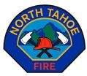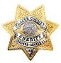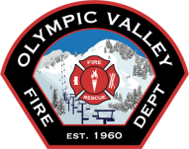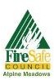

2022 “Area of Refuge” Evacuation Drill
in Olympic Valley; Aug 27th; 9:30-11:00 AM
============
Palisades Tahoe Parking Lot
(north of Squaw Creek; in front of fire station)
=============
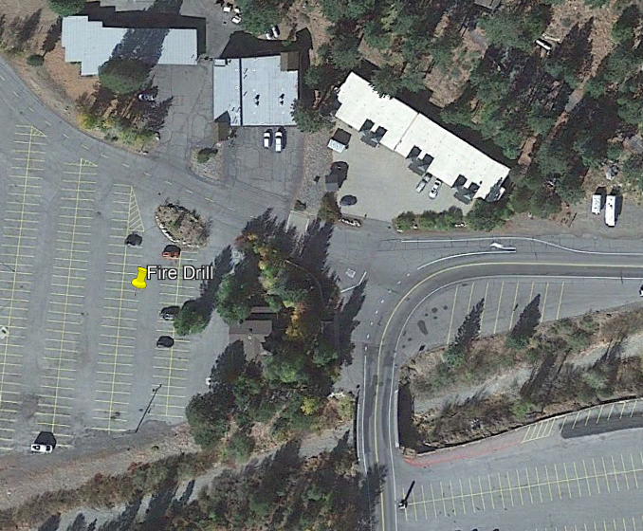
While the primary plans for wildfire in our area call for complete evacuation via 89, this drill (as last year) will simulate the limited scenario of a wildfire closing Highway 89 in both directions. In such a scenario, existing fire plans employ the ski resort parking lots as “areas of refuge”.
FIRE
STN

x

SIMULATED evacuation orders will be sent thru Nixle and Nextdoor at 9:25 AM. That will be the signal to GO TO THE MEETING AREA !!
Squaw Creek
Please sign up for Placer Alert at https://www.placer.ca.gov/2426/Placer-Alert.
This system will be used in case of a real emergency.

Palisades Tahoe, Olympic Valley Fire, Cal Fire, North Tahoe Fire, Placer County Sheriff, CHP, and Olympic Valley Firewise Committee will make brief presentations. Dee Byrne will make some closing remarks can take questions.

We encourage everyone to participate !!

